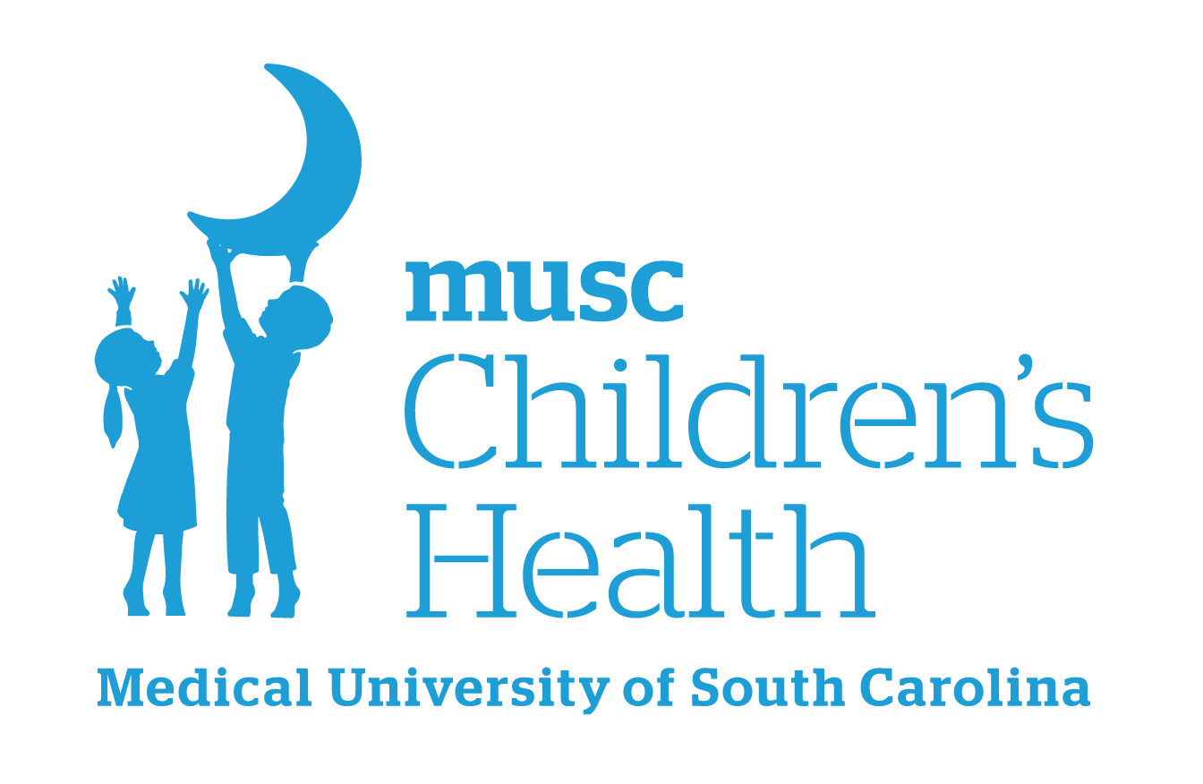

Boeing Center for Children’s Wellness
Sample Birthday Policy- One Class Party per Month

Celebrating our students’ birthdays is very important to us. (SCHOOL NAME) is dedicated to sending a consistent message about proper nutrition so our celebrations will reflect the healthy changes being made throughout our school building. In our continued efforts to promote wellness for our students and staff, classroom birthday celebrations that include unhealthy foods (those that do not meet USDA Smart Snack standards) will be limited to one per month. The monthly birthday celebration will not include more than one food or beverage that does not meet USDA Smart Snack standards.

This policy will not be successful without the full participation of parents and school staff as we set a positive example and model healthy behaviors for our students.

______________________________________
Principal’s Signature

______________________________________
Effective Date

Sources:
Action for Healthy Kids. Healthy & Active Parties
Action for Healthy Kids. Healthy & Active Non-Food Rewards
Alliance for a Healthier Generation resources for healthy celebrations and nonfood rewards
For more ideas and resources, please visit our website:
Boeing Center Resources
Please contact your school’s Wellness Leader or boeingcenter@musc.edu with any questions.
Version 2 – August 2025
Boeing Center for Children’s Wellness
Sample Birthday Policy- More Than One Class Party Per Month

We the staff of _______________________________________ commit to healthier students by instituting a policy on healthy birthday parties at our school. We are trying to set a positive example and model healthy behaviors for our students. This policy will not be successful without full participation of parents and school staff. If a class chooses to recognize each student’s birthday individually, the foods and beverages offered must meet nutrition standards of the USDA School Snacks/Food/Beverage guidelines. Classes may also celebrate each student’s birthday with non-food related activities.

This policy will not be successful without the full participation of parents and school staff as we set a positive example and model healthy behaviors for our students.

______________________________________
Principal’s Signature

______________________________________
Effective Date

Sources:
Action for Healthy Kids. Healthy & Active Parties
Action for Healthy Kids. Healthy & Active Non-Food Rewards
Alliance for a Healthier Generation resources for healthy celebrations and nonfood rewards

For more ideas and resources, please visit our website:
Boeing Center Resources
Please contact your school’s Wellness Leader or boeingcenter@musc.edu with any questions.
Version 2 – August 2025

