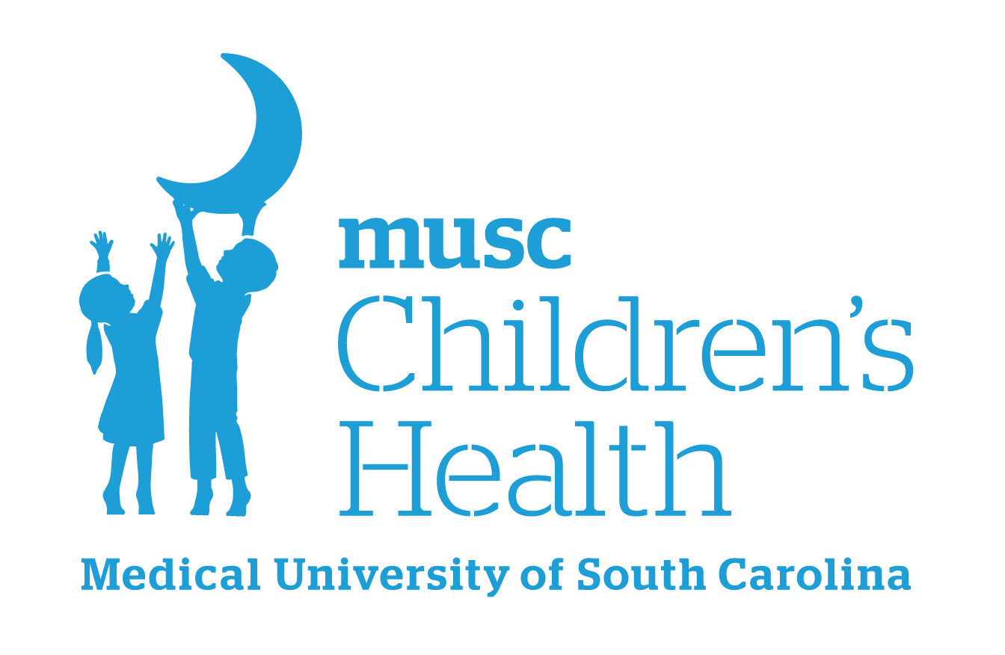
Boeing Center for Children’s Wellness
Sample Celebration Policy

Celebrating the achievements of our students is very important to us. (SCHOOL NAME) is dedicated to sending a consistent message about proper nutrition so our celebrations will reflect the healthy changes being made throughout our school building. In our continued efforts to promote wellness for our students and staff, all classroom or club achievements will be celebrated with non-food rewards or healthy foods. Unhealthy foods that do not align with the USDA Smart Snack regulations are not permitted at school celebrations.

This policy will not be successful without the full participation of parents and school staff as we set a positive example and model healthy behaviors for our students.

______________________________________
Principal’s Signature

______________________________________
Effective Date

Sources:
Action for Healthy Kids. Healthy & Active Parties
Action for Healthy Kids. Healthy & Active Non-Food Rewards
Alliance for a Healthier Generation resources for healthy celebrations and nonfood rewards

For more ideas and resources, please visit our website:
Boeing Center Resources
Please contact your school’s Wellness Leader or boeingcenter@musc.edu with any questions.
Version 2 – August 2025

