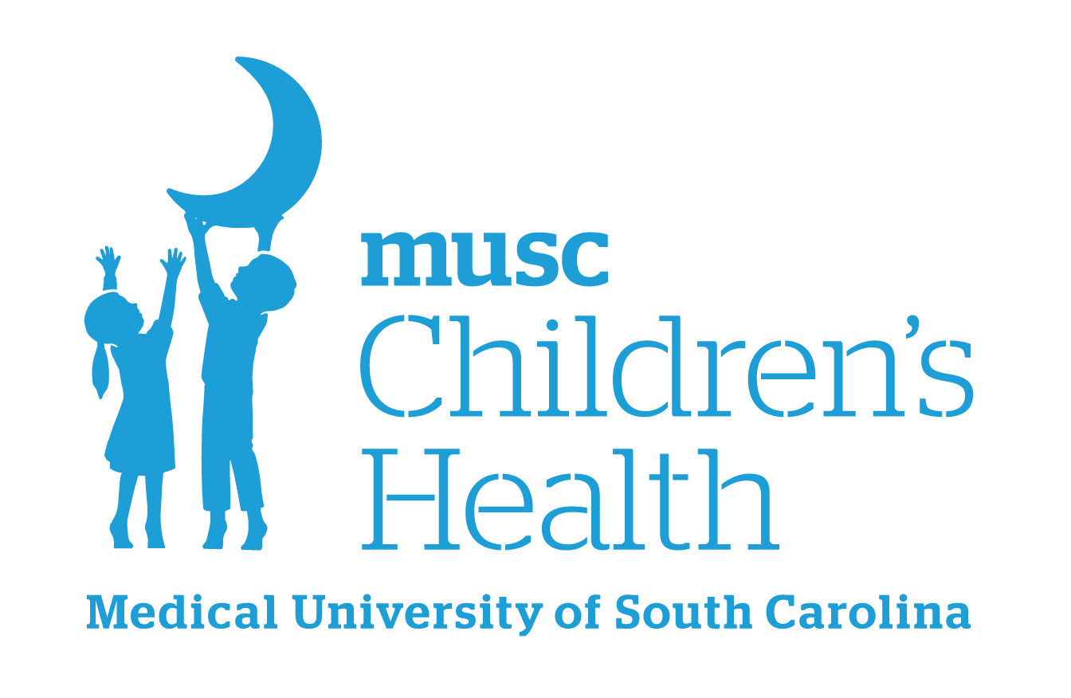
Boeing Center for Children’s Wellness
Water Drinking Policy

Drinking water can contribute to good health and schools are in a unique position to promote healthy dietary behaviors, including drinking water. Ensuring that students have access to safe, free drinking water throughout the school environment gives them a healthy alternative to sugar-sweetened beverages before, during, and after school. Access to safe, free drinking water helps to increase students’ overall water consumption, maintain hydration, and reduce energy intake, if substituted for sugar-sweetened beverages. In addition, adequate hydration may improve cognitive function among children and adolescents, which is important for learning.

Here at (SCHOOL NAME), we are committed to providing students, faculty, and visitors with free, safe, and unflavored drinking water throughout the day. Students are permitted to carry a clear, non-glass bottle containing water in the hallways and classrooms. Students are prohibited from drinking non-water beverages in the hallways and classrooms. Students are encouraged to refill their water bottles throughout the day. Faculty and visitors are strongly encouraged to be role models for students and only drink water in the hallways and classrooms.

Adapted from: https://www.cdc.gov/healthyschools/npao/wateraccess.htm

______________________________________
Principal’s Signature

______________________________________
Effective Date

For more ideas and resources, please visit our website:
Boeing Center Resources
Please contact your school’s Wellness Leader or boeingcenter@musc.edu with any questions.
Version 2 – August 2025

