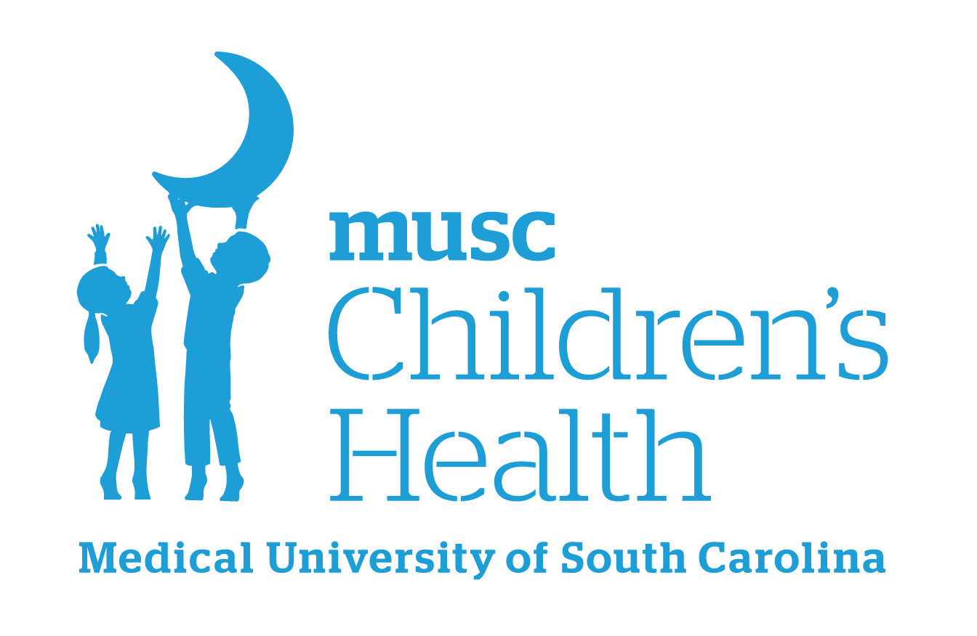
Boeing Center for Children’s Wellness
Wellness Committee Action Plan and Guiding Questions

Guiding Questions:

1. What are the top 3-5 goals we would like to focus on as a wellness committee team? Frame these goals as SMART Goals and use your universal screener data, staff wellness survey, and Healthier Generation’s Healthy Schools Assessment, and school-wide SEL assessment results.
*SMART: Specific, Measurable, Attainable, Relevant, and Time-Bound
2. Which specific actions or activities will your team focus on and what volunteer support or resources will be needed?
3. What school leadership teams currently exist that we could collaborate with to align our action planning goals?
4. Do these proposed action items align with our schools vision and goals?

Action/Activity | Who is responsible? | When will it be started? | When will it be completed? | When/how will we evaluate it?

For more ideas and resources, please visit our website:
Boeing Center Resources
Please contact your school’s Wellness Leader or boeingcenter@musc.edu with any questions.
Version 2 – August 2025

